https://nl.mathworks.com/help/phased/ug/improve-snr-and-capacity-of-wireless-communication-using-antenna-arrays.html?s_tid=srchtitle_site_search_9_wireless+diversity

https://nl.mathworks.com/help/phased/ug/improve-snr-and-capacity-of-wireless-communication-using-antenna-arrays.html?s_tid=srchtitle_site_search_9_wireless+diversity

Improve SNR and Capacity of Wireless Communication Using Antenna Arrays
The goal of a wireless communication system is to serve as many users with the highest possible data rate given constraints such as radiation power limit and operating budget. To improve the data rate, the key is to improve the signal to noise ratio (SNR). To serve more users, the key is to reuse the resources. Over the last several decades, numerous algorithms have been adopted to improve the SNR and reuse the resources in time, frequency, and coding spaces. This example shows how the adoption of antenna arrays can help improve the SNR and capacity of a wireless link.

Introduction
Antenna arrays have become part of the standard configuration in 5G wireless communication systems. Because there are multiple elements in an antenna array, such wireless communications systems are often referred to as multiple input multiple output (MIMO) systems. Antenna arrays can help improve the SNR by exploring the redundancy across the multiple transmit and receive channels. They also make it possible to reuse the spatial information in the system to improve the coverage.
For this example, assume the system is deployed at 60 GHz, which is a frequency being considered for the 5G system.
c = 3e8; % propagation speed
fc = 60e9; % carrier frequency
lambda = c/fc; % wavelength

rng(6466);
With no loss in generality, place the transmitter at the origin and place the receiver approximately 1.6 km away.
txcenter = [0;0;0];
rxcenter = [1500;500;0];
Throughout this example, the scatteringchanmtx function will be used to create a channel matrix for different transmit and receive array configurations. The function simulates multiple scatterers between the transmit and receive arrays. The signal travels from the transmit array to all the scatterers first and then bounces off the scatterers and arrives at the receive array. Therefore, each scatterer defines a signal path between the transmit and the receive array and the resulting channel matrix describes a multipath environment. The function works with antenna arrays of arbitrary size at any designated frequency band.

Improve SNR by Array Gain for Line of Sight Propagation
The simplest wireless channel is a line of sight (LOS) propagation. Although simple, such channels can often be found in rural areas. Adopting an antenna array under such situations can improve the signal to noise ratio at the receiver and in turn improve the communication link's bit error rate (BER).
SISO LOS Channel
Before discussing the performance of a MIMO system, it is useful to build a baseline with a single input single output (SISO) communication system. A SISO LOS channel has a direct path from the transmitter to the receiver. Such a channel can be modeled as a special case of the multipath channel.
[~,txang] = rangeangle(rxcenter,txcenter);
[~,rxang] = rangeangle(txcenter,rxcenter);

txsipos = [0;0;0];
rxsopos = [0;0;0];

g = 1; % gain for the path
sisochan = scatteringchanmtx(txsipos,rxsopos,txang,rxang,g);
Using BPSK modulation, the bit error rate (BER) for such a SISO channel can be plotted as
Nsamp = 1e6;
x = randi([0 1],Nsamp,1);

ebn0_param = -10:2:10;
Nsnr = numel(ebn0_param);

ber_siso = helperMIMOBER(sisochan,x,ebn0_param)/Nsamp;
helperBERPlot(ebn0_param,ber_siso);
legend('SISO')
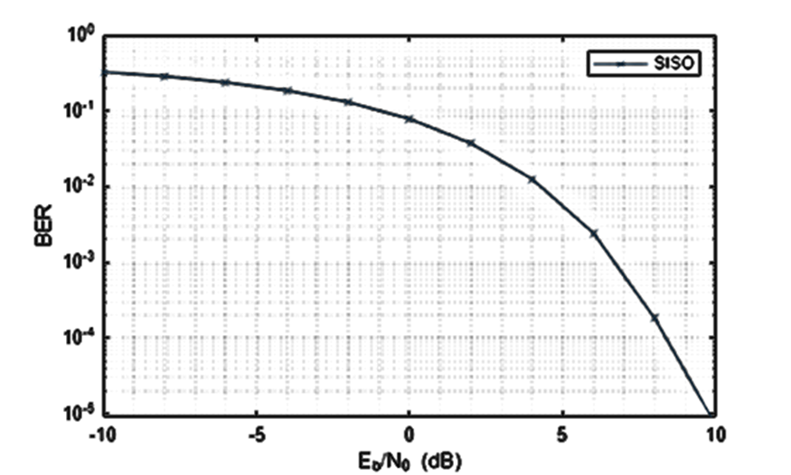
SIMO LOS Channel
With the baseline established for a SISO system, this section focuses on the single input multiple output (SIMO) system. In such a system, there is one transmit antenna but multiple receive antennas. Again, it is assumed that there is a direct path between the transmitter and the receiver.
Assume the receive array is a 4-element ULA with half-wavelength spacing, then the SIMO channel can be modeled as
rxarray = phased.ULA('NumElements',4,'ElementSpacing',lambda/2);
rxmopos = getElementPosition(rxarray)/lambda;

simochan = scatteringchanmtx(txsipos,rxmopos,txang,rxang,g);
In the SIMO system, because the received signals across receive array elements are coherent, it is possible to steer the receive array toward the transmitter to improve the SNR. Note that this assumes that the signal incoming direction is known to the receiver. In reality, the angle is often obtained using direction of arrival estimation algorithms.
rxarraystv = phased.SteeringVector('SensorArray',rxarray,...
'PropagationSpeed',c);
wr = conj(rxarraystv(fc,rxang));
ber_simo = helperMIMOBER(simochan,x,ebn0_param,1,wr)/Nsamp;
helperBERPlot(ebn0_param,[ber_siso(:) ber_simo(:)]);
legend('SISO','SIMO')

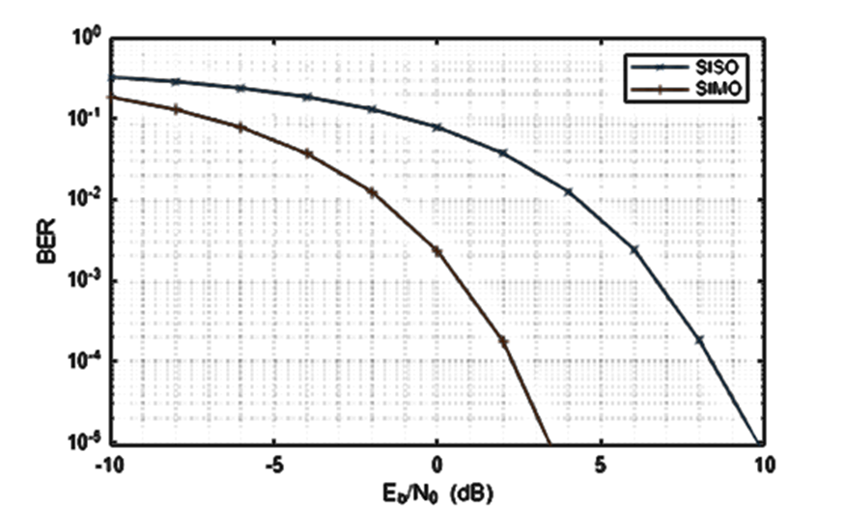

The BER curve shows a gain of 6 dB provided by the receive array.
MISO LOS Channel
The multiple input single output (MISO) system works in a similar way. In this case, the transmitter is a 4-element ULA with half-wavelength spacing.
txarray = phased.ULA('NumElements',4,'ElementSpacing',lambda/2);
txmipos = getElementPosition(txarray)/lambda;

misochan = scatteringchanmtx(txmipos,rxsopos,txang,rxang,g);
A line of sight MISO system achieves best SNR when the transmitter has the knowledge of the receiver and steers the beam toward the receiver. In addition, to do a fair comparison with the SISO system, the total transmitter power should be the same under both situations.
txarraystv = phased.SteeringVector('SensorArray',txarray,...
'PropagationSpeed',c);
wt = txarraystv(fc,txang)';
ber_miso = helperMIMOBER(misochan,x,ebn0_param,wt,1)/Nsamp;
helperBERPlot(ebn0_param,[ber_siso(:) ber_simo(:) ber_miso(:)]);
legend('SISO','SIMO','MISO')
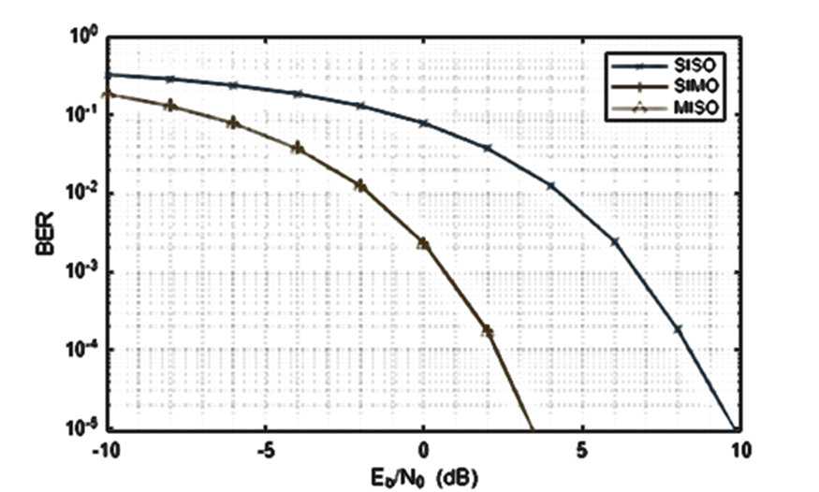
Note that with the pre-steering, the performance of MISO matches the performance of a SIMO system, gaining 6 dB in SNR. It may not be as intuitive compared to the SIMO case because the total transmit power does not increase. However, by replacing a single isotropic antenna with a 4-element transmit array, a 6 dB gain is achieved.
MIMO LOS Channel
Because a SIMO system provides an array gain from the received array and a MISO system provides an array gain from the transmit array, a MIMO system with an LOS propagation can benefit from both the transmit and receive array gain.
Assume a MIMO system with a 4-element transmit array and a 4-element receive array.
mimochan = scatteringchanmtx(txmipos,rxmopos,txang,rxang,g);
To achieve the best SNR, the transmit array and the receive array need to be steered toward each other. With this configuration, the BER curve can be computed as
wt = txarraystv(fc,txang)';
wr = conj(rxarraystv(fc,rxang));
ber_mimo = helperMIMOBER(mimochan,x,ebn0_param,wt,wr)/Nsamp;
helperBERPlot(ebn0_param,[ber_siso(:) ber_simo(:) ber_mimo(:)]);
legend('SISO','SIMO','MIMO')
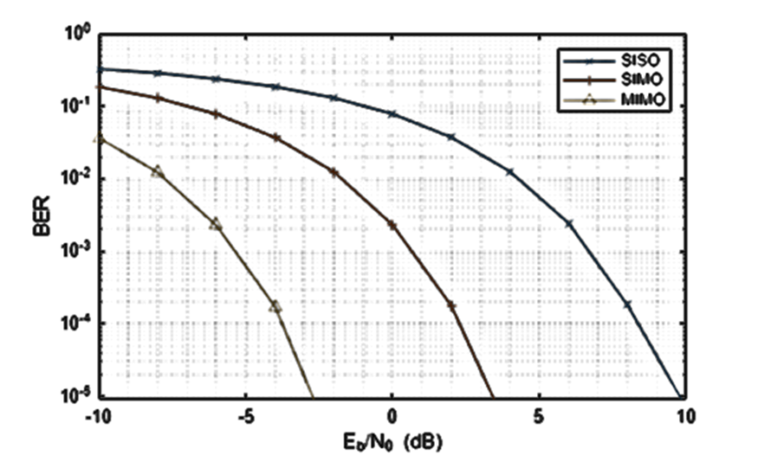
As expected, the BER curve shows that both the transmit array and the receive array contributes a 6 dB array gain, resulting in a total gain of 12 dB over the SISO case.

Improve SNR by Diversity Gain for Multipath Channel
All the channels in the previous sections are line-of-sight channels. Although such channels are found in some wireless communication systems, in general wireless communications occurs in multipath fading environments. The rest of this example explores how using arrays can help in a multipath environment.
SISO Multipath Channel
Assume there are 10 randomly placed scatterers in the channel, then there will be 10 paths from the transmitter to the receiver, as illustrated in the following figure.
Nscat = 10;

[~,~,~,scatpos] = ...
helperComputeRandomScatterer(txcenter,rxcenter,Nscat);
helperPlotSpatialMIMOScene(txsipos,rxsopos,...
txcenter,rxcenter,scatpos);
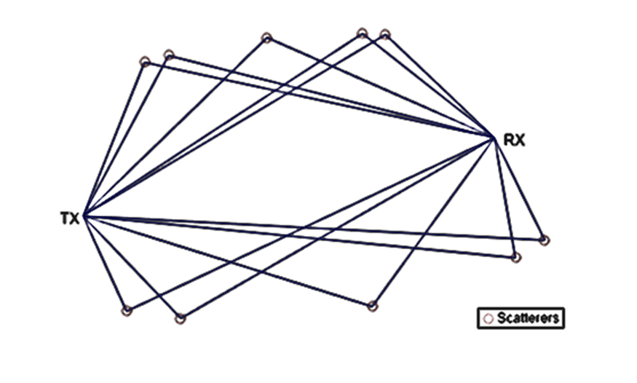
For simplicity, assume that signals traveling along all paths arrive within the same symbol period so the channel is frequency flat.
To simulate the BER curve for a fading channel, the channel needs to change over time. Assume we have 1000 frames and each frame has 10000 bits. The baseline SISO multipath channel BER curve is constructed as
Nframe = 1e3;
Nbitperframe = 1e4;
Nsamp = Nframe*Nbitperframe;

x = randi([0 1],Nbitperframe,1);

nerr = zeros(1,Nsnr);

for m = 1:Nframe
sisompchan = scatteringchanmtx(txsipos,rxsopos,Nscat);
wr = sisompchan'/norm(sisompchan);
nerr = nerr+helperMIMOBER(sisompchan,x,ebn0_param,1,wr);
end
ber_sisomp = nerr/Nsamp;
helperBERPlot(ebn0_param,[ber_siso(:) ber_sisomp(:)]);
legend('SISO LOS','SISO Multipath');
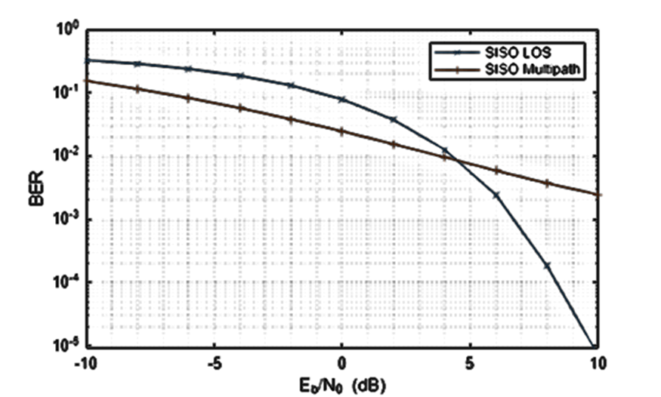
Compared to the BER curve derived from an LOS channel, the BER falls off much slower with the increase of energy per bit to noise power spectral density ratio (Eb/N0) due to the fading caused by the multipath propagation.
SIMO Multipath Channel
As more receive antennas are used in the receive array, more copies of the received signals are available at the receiver. Again, assume a 4-element ULA at the receiver.
The optimal combining weights can be derived by matching the channel response. Such a combining scheme is often termed as maximum ratio combining (MRC). Although in theory such scheme requires the knowledge of the channel, in practice the channel response can often be estimated at the receive array.
nerr = zeros(1,Nsnr);

for m = 1:Nframe
simompchan = scatteringchanmtx(txsipos,rxmopos,Nscat);
wr = simompchan'/norm(simompchan);
nerr = nerr+helperMIMOBER(simompchan,x,ebn0_param,1,wr);
end
ber_simomp = nerr/Nsamp;
helperBERPlot(ebn0_param,[ber_sisomp(:) ber_simomp(:)]);
legend('SISO Multipath','SIMO Multipath');
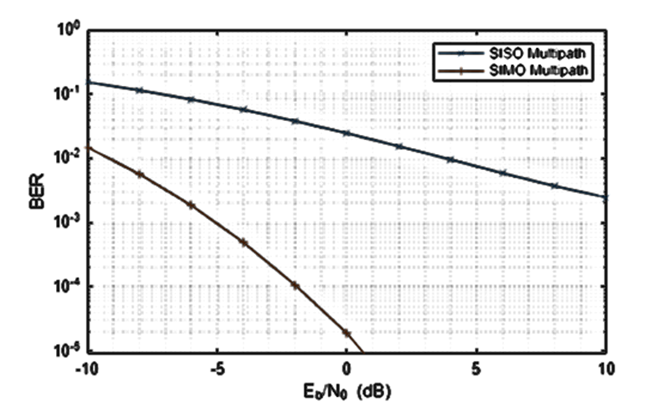
Note that the received signal is no longer weighted by a steering vector toward a specific direction. Instead, the receiving array weights in this case are given by the complex conjugate of the channel response. Otherwise it is possible that multipath could make the received signal out of phase with the transmitted signal. This assumes that the channel response is known to the receiver. If the channel response is unknown, pilot signals can be used to estimate the channel response.
It can be seen from the BER curve that not only the SIMO system provides some SNR gains compared to the SISO system, but the slope of the BER curve of the SIMO system is also steeper compared to the BER curve of the SISO system. The gain resulted from the slope change is often referred to as the diversity gain.
MISO Multipath Channel
Things get more interesting when there is multipath propagation in a MISO system. First, if the channel is known to the transmitter, then the strategy to improve the SNR is similar to maximum ratio combining. The signal radiated from each element of the transmit array should be weighted so that the propagated signal can be added coherently at the receiver.
nerr = zeros(1,Nsnr);

for m = 1:Nframe
misompchan = scatteringchanmtx(txmipos,rxsopos,Nscat);
wt = misompchan'/norm(misompchan);
nerr = nerr+helperMIMOBER(misompchan,x,ebn0_param,wt,1);
end
ber_misomp = nerr/Nsamp;

helperBERPlot(ebn0_param,[ber_sisomp(:) ber_simomp(:) ber_misomp(:)]);
legend('SISO Multipath','SIMO Multipath','MISO Multipath');
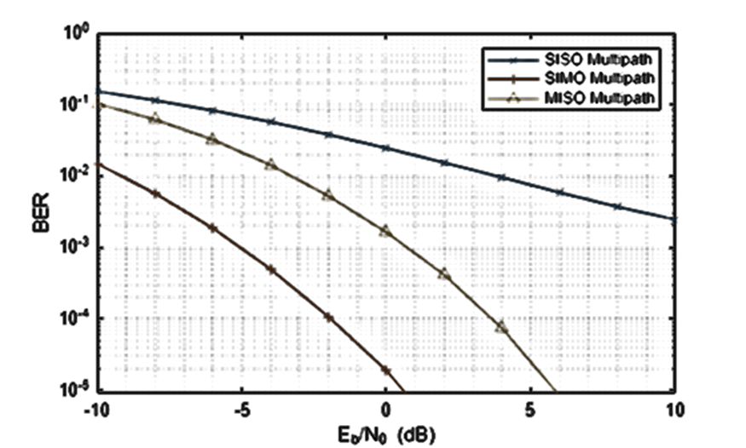
Note the transmit diversity gain shown in the BER curve. Compared to the SIMO multipath channel case, the performance of a MISO multipath system is not as good. This is because there is only one copy of the received signal yet the transmit power gets spread among multiple paths. It is certainly possible to amplify the signal at the transmit side to achieve an equivalent gain, but that introduces additional cost.
If the channel is not known to the transmitter, there are still ways to explore the diversity via space time coding. For example, Alamouti code is a well known coding scheme that can be used to achieve diversity gain when the channel is not known. Interested readers are encouraged to explore the Introduction to MIMO Systems example in Communications Toolbox™.
MIMO Multipath Channel
The rest of this example focuses on a multipath MIMO channel. In particular, this section illustrates the case where the number of scatterers in the environment is larger than the number of elements in the transmit and receive arrays. Such an environment is often termed as a rich scattering environment.
Before diving into the specific performance measures, it is helpful to get a quick illustration of what the channel looks like. The following helper function creates a 4x4 MIMO channel where both transmitter and receiver are 4-element ULAs.
[txang,rxang,scatg,scatpos] = ...
helperComputeRandomScatterer(txcenter,rxcenter,Nscat);
mimompchan = scatteringchanmtx(txmipos,rxmopos,txang,rxang,scatg);
There are multiple paths available between the transmit array and the receive array because of the existence of the scatterers. Each path consists of a single bounce off the corresponding scatterer.
helperPlotSpatialMIMOScene(txmipos,rxmopos,txcenter,rxcenter,scatpos);
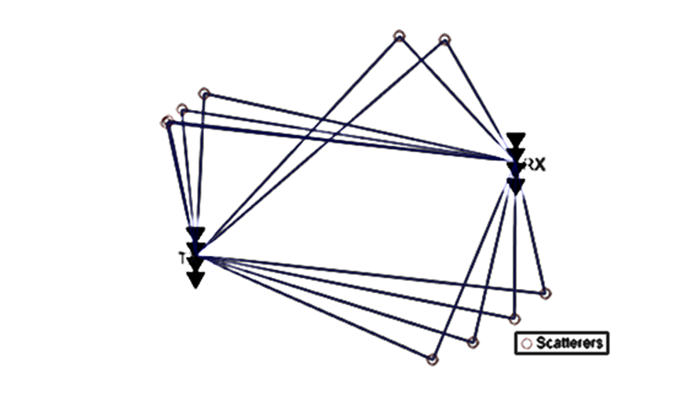
There are two ways to take advantage of a MIMO channel. The first way is to explore the diversity gain offered by a MIMO channel. Assuming the channel is known, the following figure shows the diversity gain with the BER curve.
nerr = zeros(1,Nsnr);

for m = 1:Nframe
mimompchan = scatteringchanmtx(txmipos,rxmopos,Nscat);
[u,s,v] = svd(mimompchan);
wt = u(:,1)';
wr = v(:,1);
nerr = nerr+helperMIMOBER(mimompchan,x,ebn0_param,wt,wr);
end
ber_mimomp = nerr/Nsamp;

helperBERPlot(ebn0_param,[ber_sisomp(:) ber_simomp(:) ber_mimomp(:)]);
legend('SISO Multipath','SIMO Multipath','MIMO Multipath');
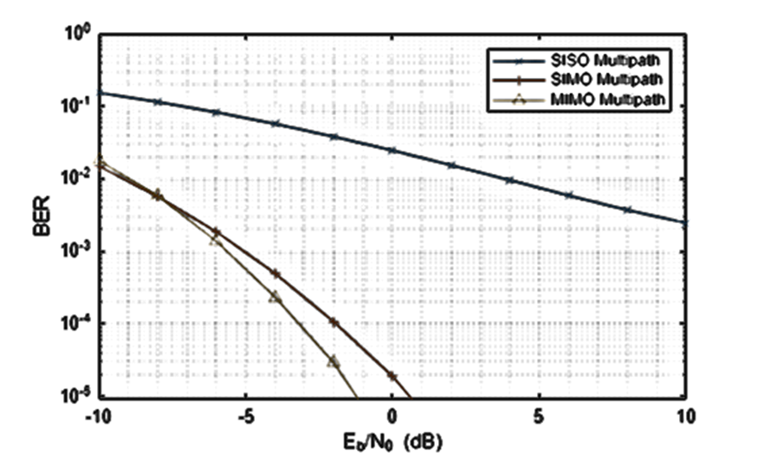
Compare the BER curve from a MIMO channel with the BER curve obtained from a SIMO system. In the multipath case, the diversity gain from a MIMO channel is not necessarily better than the diversity gain provided by a SIMO channel. This is because to obtain the best diversity gain, only the dominant mode in a MIMO channel is used yet there are other modes in the channel that are not used. So is there an alternative way to utilize the channel?

